Module 6 - Spring Data JPA with Spring Boot, Hibernate
Spring Data JPA - Difference between JPA, Hibernate and Spring Data JPA

Project Structure
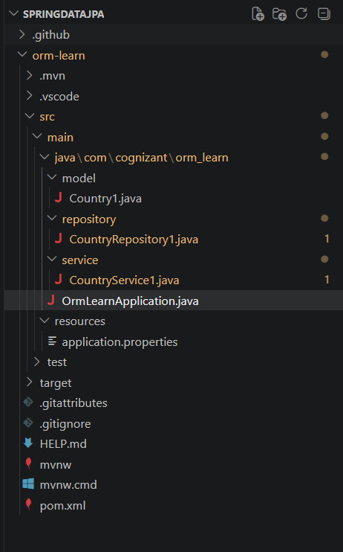

Entity
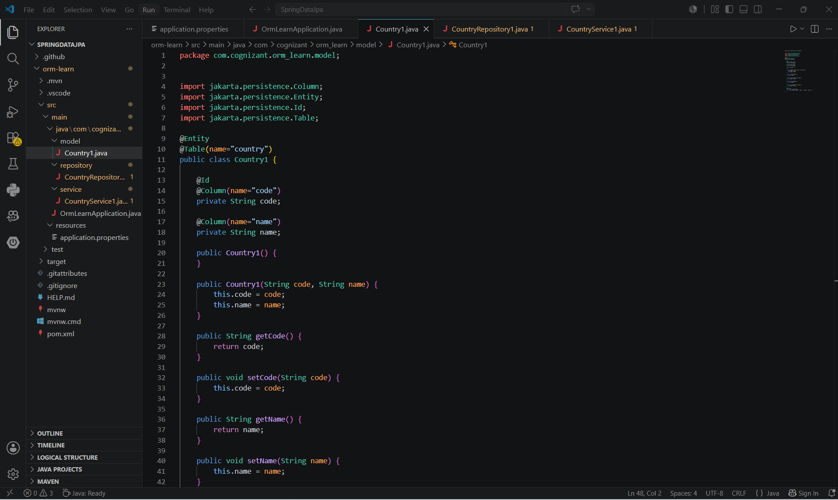
Repository
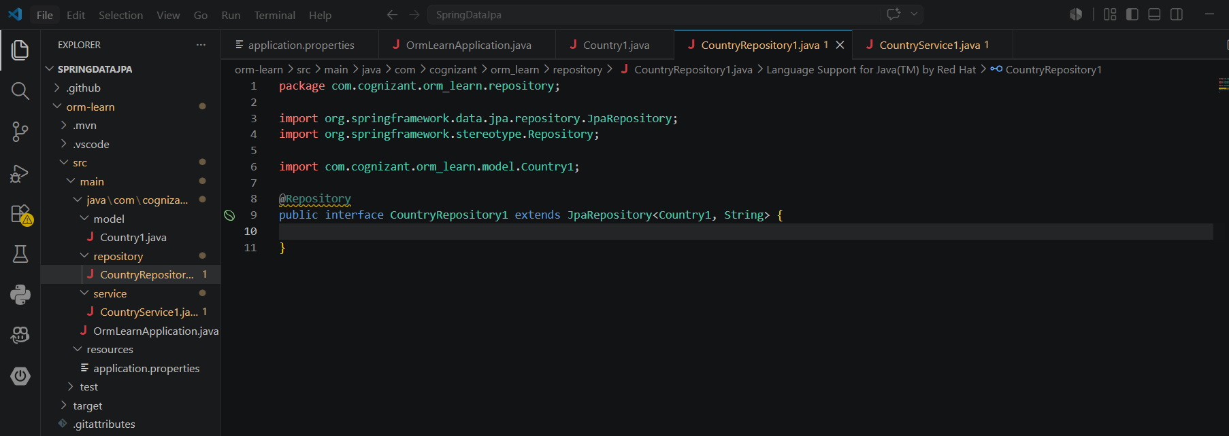

Service
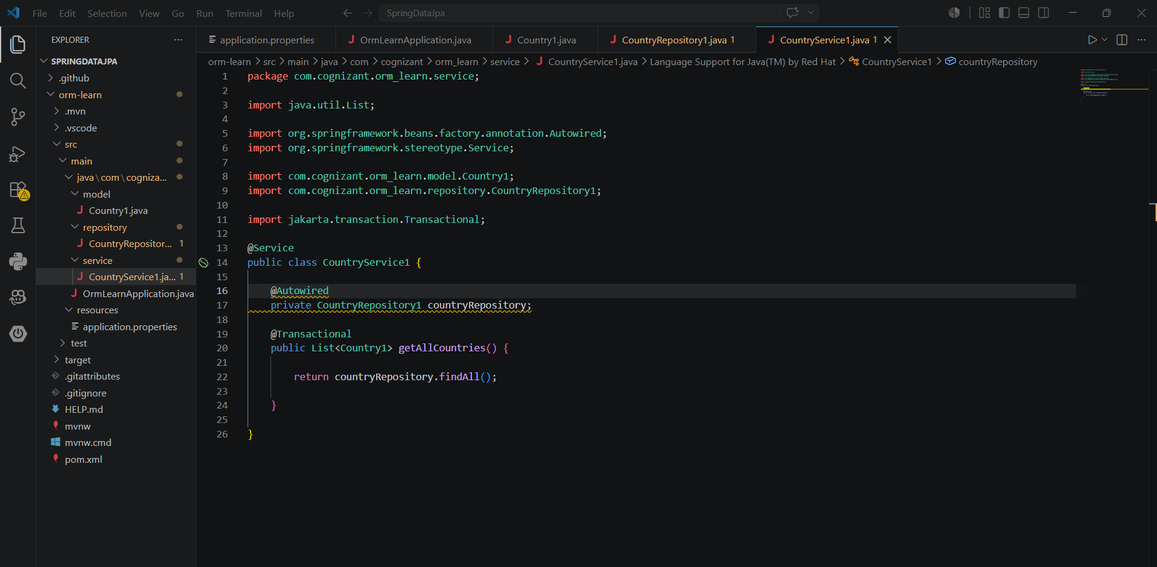
Output
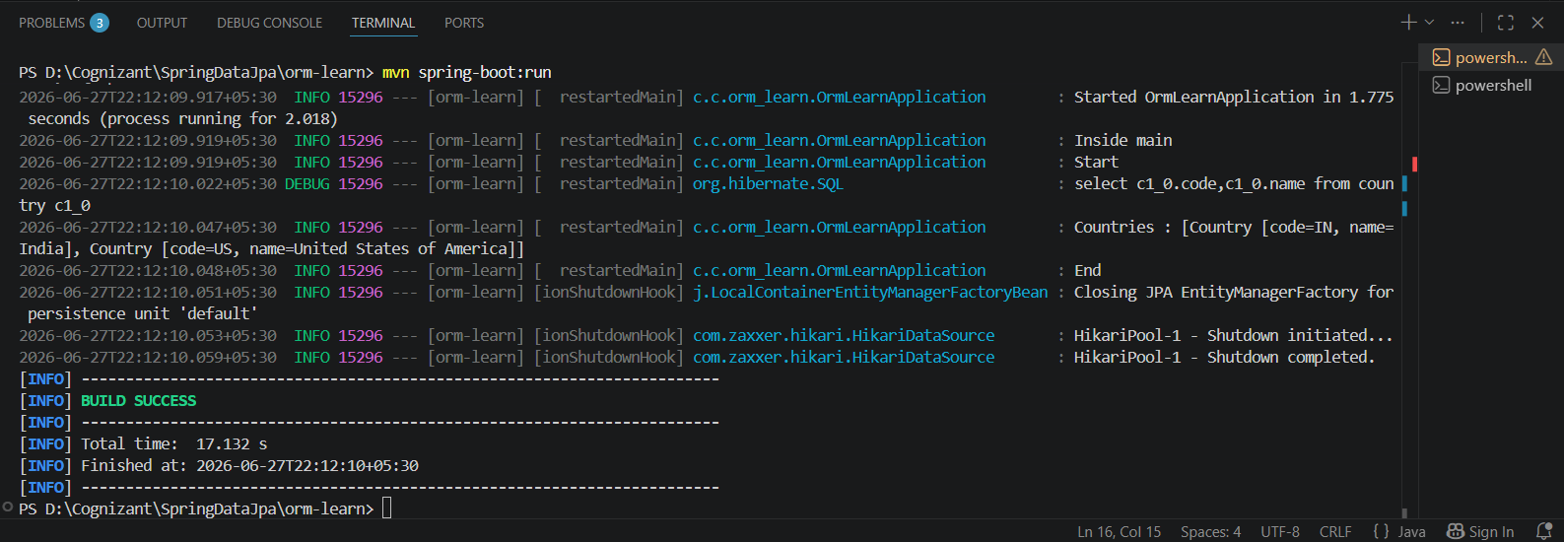

Java Persistence API (JPA)

Definition
Java Persistence API (JPA) is a standard Java specification used for Object-Relational Mapping (ORM). It provides a common set of interfaces and annotations to map Java classes to database tables. Since JPA is only a specification, it requires an implementation such as Hibernate to perform database operations.

Features
- Standard specification for data persistence in Java.
- Uses annotations like @Entity, @Table, @Id, and @Column.
- Provides a consistent programming model for ORM.
- Requires an implementation framework such as Hibernate.

Advantages
- Independent of any specific database vendor.
- Offers a standardized approach to persistence.
- Makes it easier to switch between different JPA implementations.

Hibernate

Definition
Hibernate is an ORM framework that serves as one of the most widely used implementations of the JPA specification. It simplifies database interaction by automatically mapping Java objects to relational database tables.

Features
- Fully supports the JPA specification.
- Eliminates the need for writing most SQL queries manually.
- Provides Hibernate Query Language (HQL) for database queries.
- Includes advanced features such as caching, lazy loading, and transaction handling.

Advantages
- Minimizes repetitive SQL code.
- Automatically manages object-to-table mapping.
- Improves application performance through caching.
- Supports powerful ORM capabilities for enterprise applications.

Spring Data JPA

Definition
Spring Data JPA is a module of the Spring Framework that builds on top of JPA. It simplifies data access by automatically providing implementations for repository interfaces, significantly reducing boilerplate code.

Features
- Works with JPA implementations like Hibernate.
- Generates CRUD operations automatically.
- Uses repository interfaces such as JpaRepository.
- Supports transaction management with @Transactional.
- Allows custom query methods without extensive SQL coding.

Advantages
- Reduces development time with less code.
- Makes database operations simple and maintainable.
- Automatically implements repository methods.
- Improves productivity when developing Spring Boot applications.

